Task5

D1:

1. Threshold = -100



1. Threshold = -1

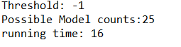

D2:

1. Threshold = -100

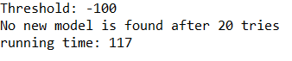

1. Threshold = -1

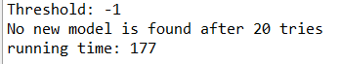

D3:

1. Threshold = -100



1. Threshold = -1

